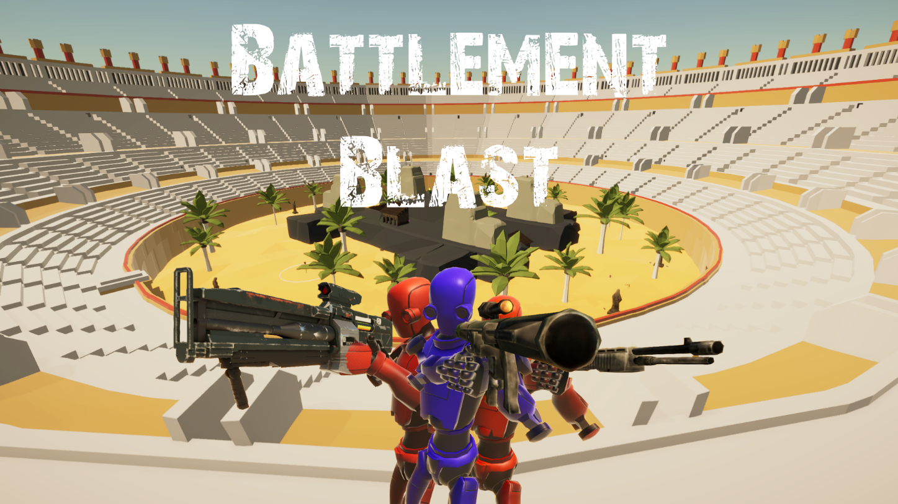

Battlement Blast
by C.A.R.L.

Brock Sokevitz

Jake Ruth

Lucas Puskaric

Rickie Kidwell

Ryan Stutzman

Alex Barnes
Contents
Battlement Blast 1
Game Concept 3
Core Mechanics 3
Networked Game 3
Basic Controls 4
Protect Spawn Core 4
Build Buildings 5
Gather Resources 5
Capture Points 6
The Emperor 6
Communication 7
Purchase Weapons 7
Game State Diagram 8
Weapons 9
Schedule 10
Timebox #2 10
Timebox #3 10
Timebox #4 10
Timebox #5 11
Timebox #6 12
After Timebox #6 12

Game Concept
Battlement Blast is a First-Person Shooter which you play in games of up to 12 people. There are 2 teams, Red and Blue. After loading into the game there will be a series of rounds. Each round begins with a three-minute build phase where you can build up defenses. The objective is to destroy the other team’s Spawn Core, while protecting your own. If your spawn core is destroyed, you will no longer respawn. Once a team has had its Spawn Core destroyed and all players on that team die, the other team wins and a new round begins. All the while, The Emperor will sit in judgement of your team, and will either help or hurt you depending on how entertained he is.

Core Mechanics
Battlement Blast is a blast to play with friends, but there are a few main mechanics involved in it. These mechanics will now be discussed in greater detail.

Networked Game
This game is played over the internet or a network. To get into an internet game, you’ll connect either create or connect to a game, or use matching making to find a game. To get into a network game, you’ll either have to host one yourself or connect to an IP address on your network. Regardless of how you do it, you’ll end up in a lobby where you can choose a name and your team, then ready up if you’re ready. Whoever the first person in the game was will become the host, and the rest will be clients connected to the host. Once all players are ready, the game will begin.
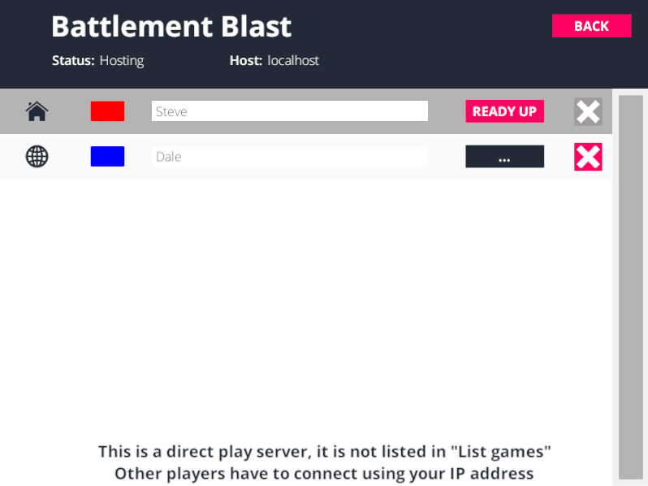

Basic Controls
You move around in the game with mostly traditional FPS controls. You can move with WASD, sprint with Shift, and jump with Space. You can also access the Buy menu with ‘V’, the build menu with ‘B’, talk with ‘T’, and reload with ‘R’. Also in the menus 1, 2, 3, 4, and 5 are used to operate them.

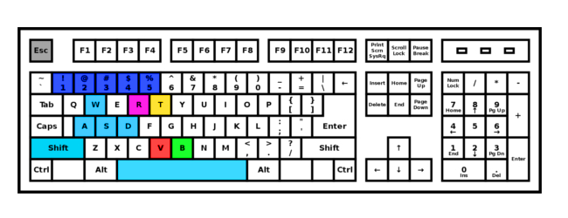

Protect Spawn Core
Your Spawn Core is what allows you to respawn. If it is destroyed, your team will stop respawning, and if your whole team is dead, you lose and a new round begins. Your primary build objective is to keep opponents from being able to destroy it easily. Here’s a picture of a spawn core:
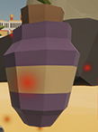

Build Buildings
Your Spawn Core is completely undefended initially. To defend it, you’ll have to build buildings. You can build 5 types of buildings: Floors, Walls, Ceilings, Doors, and Stairs.
Floors can be built on the ground, and the other 4 can be built on floors and in certain cases each other. You press ‘B’ to access the build menu, and left click to place once it turns blue. Each building costs certain quantities of wood or stone, and cannot be placed without them.
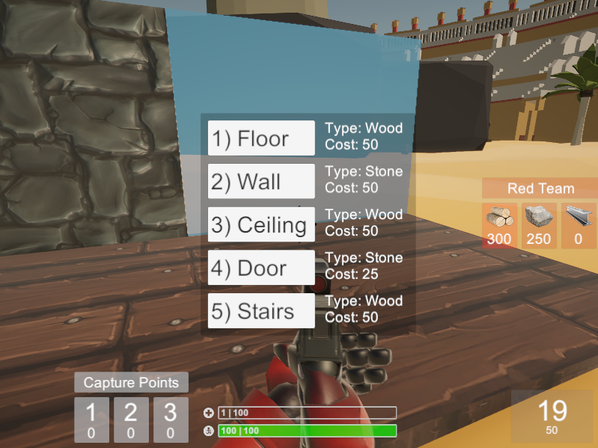

Gather Resources
Your team starts with some resources, but you’re going to need to gather some more resources to keep building and buying weapons. There are Resource pickups throughout the map. There are 3 different resources: Wood, Stone, and Metal.
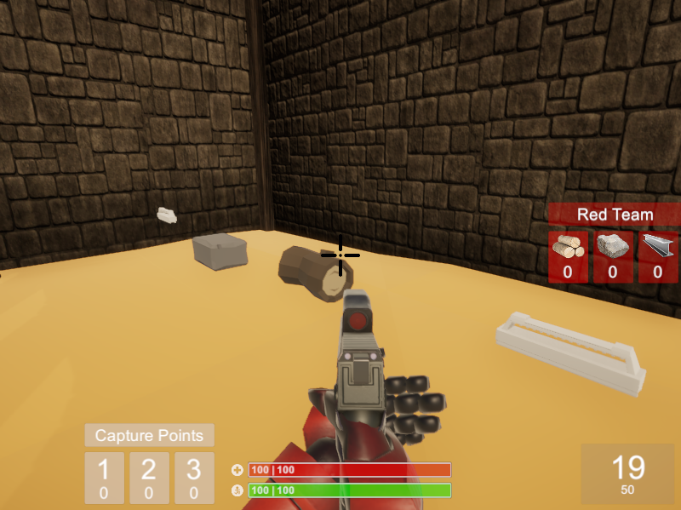

Capture Points
There is another source of resources on the map: the 3 Control points. Once your team owns a spawn point, you will receive resources every second. It takes 10 seconds to capture a point, and you can put in 10 more seconds after you capture it to make it harder for your opponents to take back.
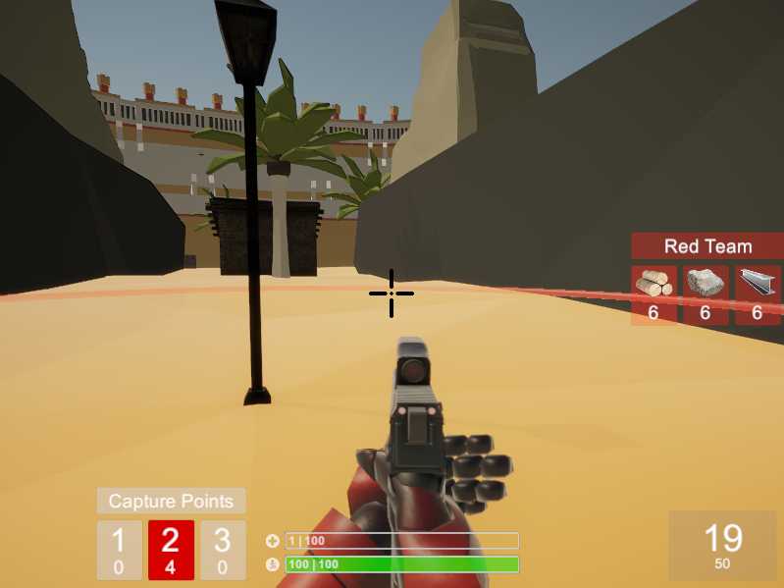

The Emperor
The Emperor will sit in judgment of your match. He has an entertainment value which lowers every second, but whenever someone dies or a building is destroyed it will increase. While he has a high entertainment value he will be in a good mood and will give gifts. While he has a low entertainment value he will be in a bad mood and punish you. He also has a favor value with both teams. If you kill someone or an enemy object, your team will gain favor. When he grants a gift, he will target the team with the most favor, then halve their current favor. When he grants a punishment, he will target the team with the least favor, then halve the other team’s favor. He is intended to keep people fighting.
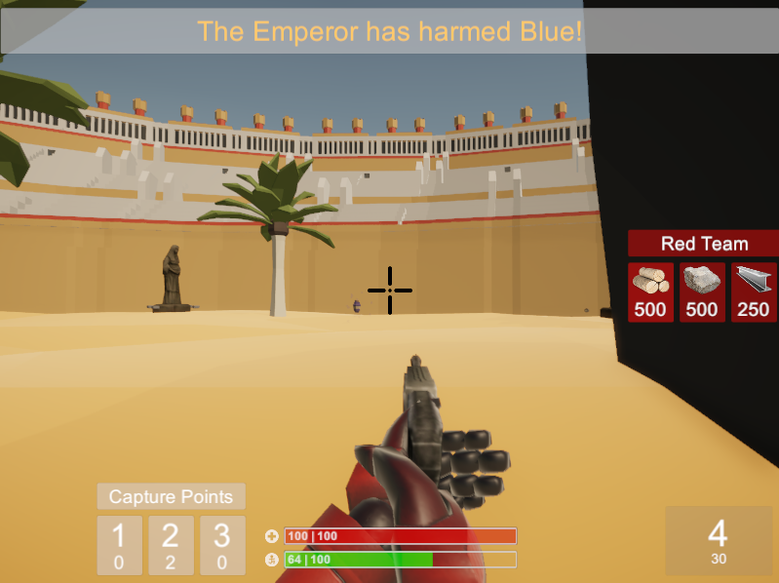

Communication
You can talk to everyone else by pressing ‘T’ and typing out messages. You can also cheat in this console. Whenever a player or a Spawn Core is destroyed a kill notification will be sent out.
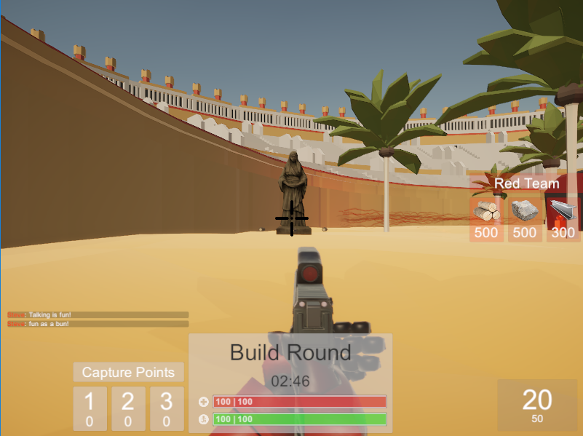

Purchase Weapons
To defeat your enemies, there are 6 guns at your disposal. Each gun has different properties. You always spawn with your pistol equipped, and can spend Metal on a new weapon by accessing the buy menu with ‘V’. Some are more expensive than others. Each gun has a different magazine capacity and reserve ammo.
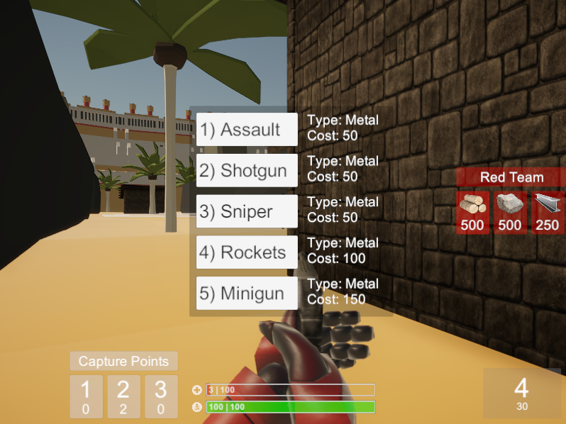

Game State Diagram

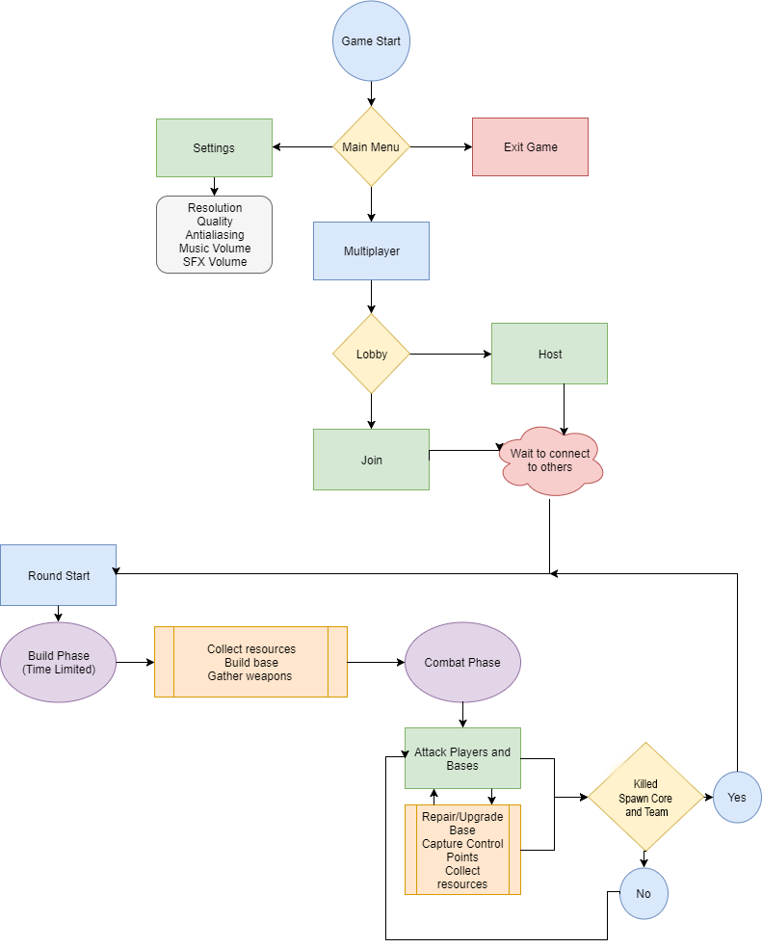

Weapons
- Pistol 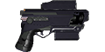
  - Semi-automatic gun which has a size 20 magazine and a reserve of 30. Each bullet does a moderate amount of damage. You start with this gun.
- Assault 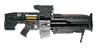
  - Fully-automatic gun with a size 30 magazine and a reserve of 150. Fires 10 projectiles a second while held down, each which does a small amount of damage. Costs 50 Metal.
- Shotgun 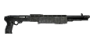
  - Semi-automatic gun with a size 5 magazine and a reserve of 30. Each shot creates 8 different projectiles with a wide random spread. Each bullet does a small amount of damage. Costs 50 Metal.
- Sniper 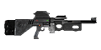
  - Bolt action gun with a size 1 magazine and a reserve of 15. Right clicking allows you to zoom, and bullets travel faster and further than normal. Each bullet does a large amount of damage. Costs 50 Metal.
- Rockets 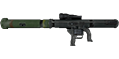
  - Semi-automatic gun with a size 4 magazine and a reserve of 20. This gun shoots rockets instead of bullets, which travel slower and don’t do damage with their impact, but causes an explosion which does a large amount of damage in a radius. Costs 100 Metal.
- Minigun 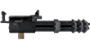
  - Fully automatic gun with a size 60 magazine and a reserve of 180. This gun fires bullets extremely rapidly (20 per second), each of which does a small amount of damage. Whenever you fire it knocks you back some. This can be used to “fly” if you fire it straight down. Costs 150 Metal.

Schedule

Timebox #2
This is what we completed for Timebox #2
- Building Framework
  - modular building using text files for snapping locations
- Building resources
  - implemented resources that will later be used for build costs
- Networking
  - sync everything over a network so we can build on it later
- Gun and damage framework
  - made a gun and target script that was reusable for people and buildings
- Colosseum
  - implemented the base level that we'll be building upon.

Timebox #3
This is what we completed for Timebox #3
- Added a floating health and name bar
  - synced between all clients, but later removed in favor of no health bars
- Made the first iteration of our multiplayer lobby
  - online multiplayer, matchmaking, and LAN supported/implemented
- added basic animations
  - running, strafing, and idle
- added postprocessing effects
  - antialiasing, ambient occlusion, bloom, color grading, vignette, and motion blur
- console commands
  - used for testing purposes
- our first iteration of base destruction
  - code was made, but we weren't using it yet, due to some bug issues
- Building updates
  - new materials/textures added
- Implemented the first iteration of teams
  - teams had colors and the color would change the weapon color
- Other Additions
  - Increased projectile speed, increased player speed, and made the first installer

Timebox #4
This is what we completed for Timebox #4
- Implemented our final arena layout
  - using 3 choke points
- Implemented Round Manager
  - Build round countdown
  - Barriers added to keep teams in their respective areas
- Implemented Build Menu
  - accessed using 'b' button
  - more intuitive than in previous timeboxes
- Implemented shaders to show destruction
  - object fades until it dies
- Messed around with terrain Destruction to build moats
  - ended up not using in the final build
- Added aiming animations
  - used inverse kinematics to determine spine rotation

Timebox #5
This is what we completed for Timebox #5
- Emperor Created
  - Implemented mechanics to determine whether the emperor is enjoying himself
  - can give out gifts if he's happy or give out punishments when he's displeased
  - gifts change based on how happy or displeased he is
- Team Building Mechanics improved
  - Teams can now build off of objects placed by members of the same team
  - made it so you couldn't build a floor or ceiling overlap
- Building Destruction finalized
  - implemented building damage and repair
  - buildings become redder as they get damaged
  - upon destruction the mesh is broken into triangles that are launched in multiple directions
- Rounds implemented
  - After a spawn core is destroyed and all players corresponding to that team are killed a new round starts
- Spawn Core Implemented
  - each team has 1 spawn core
  - Spawn core allows players belonging to that team to respawn
  - spawn cores can't be moved, but they can be built around
- UI improvements
  - made it more appealing to look at
- New Gun
  - added a fully automatic rifle
- Improved Player Lobby
  - now you can choose your team in the lobby
  - now supports up to 12 players
- Removed Friendly Fire
  - although you can still destroy your own buildings

Timebox #6
This is what we completed for Timebox #6
- Implemented fatigue
  - did this to balance sprinting
- Implemented capture point ui and location indicators
  - to make it easier to keep track of who has the capture points
  - also helps new players see where the points are
- Implemented ammo and health pickups
  - just for balance
- Implemented Notifications
  - notifies players of who kills wholeheartedly
  - notifies players when their spawn is under attack
  - also notifies players when someone disconnects
- Implemented Player chat
  - allows players to gloat and make fun of the enemy team
- Changed stair prefab
  - allowing players to build straight up if they want to.
- Implemented more weapons
  - Assault Rifle, Shotgun, Sniper, Rockets, and a Minigun
  - Each gun behaves slightly differently to give the player options
    - Assault Rifle
      - Moderate Rate of fire, decent damage, moderate sized magazine
    - Shotgun
      - scatter shot, low magazine size, low reserve ammo
    - Sniper Rifle
      - Only 1 shot before reloading, very high damage
    - Rocket Launcher
      - High radius damage, slower projectiles, explosion animation
    - Minigun
      - High fire Rate, large ammo Reserve, and knockback that allows the player to fly
- Playtested and Found some additional bugs

After Timebox #6
This is what we completed after Timebox #6
- added the team color to the model
  - improve team clarity
- removed minigun knockback when out of ammo
  - makes it so players can't fly indefinitely
- Improved Building Menu
  - made it so that it would preview the previously placed item, which was useful for placing multiple floors or walls
- Improved networking
  - eliminated most disconnects

